**CUSTOMER CARE REGISTRY**

CUSTOMER JOURNEY MAP

**TEAM DETAILS:**

**Team No:** PNT2022TMID31494

**College Name:** Dr.N.G.P.Institute of Technology

**Department:** ELECTRONICS AND COMMUNICATION ENGINEERING

**PROBLEM MEMBERS:**

* VIGNESHWARAN D
* SURESH KUMAR R
* SURIYAN D
* AZIL KRISHNAN S

PROJECT DESIGN PHASE –II CUSTOMER JOURNEY MAP DATE

|  |  |
| --- | --- |
| **DATE** | 2022 |
| **TEAM ID** | PNT2022TMID31494 |
| **PROJECTS NAME** | CUSTOMER CARE REGISTRY |
| **MAXIMUM MARKS** | 2 Marks |

|  |  |  |  |  |  |
| --- | --- | --- | --- | --- | --- |
| **STAGE** | **AWARENESS** | **CONSIDERATION** | **DECISION** | **SERVICE** | **LOYALITY** |
| CUSTOMER ACTIVITIES | View the social media, get reviews from customer | Treated respectfully, compare the cost | Recognizing problems and evaluating information and purchasing. | Attitude with people first and professionalism | Rewarding and recognition |
| TOUCH POINTS | Promising the brand, Customer experience | Social platform, database | Platforms, websites | Talkbot, web mail | Evaluate customer reviews |
| CUSTOMER  EXPERIENCE | Friendly, quick | Eagerness, fervent | inquisitive | Furious and  letdown | Contented,  associated |
| KPIS | Response from  customer | Transient, microblog | Exchange rate | Service credit and  reputability | Customer  contented rate |
| RESPONSIBL E | Kinship | conversations | Client service | Client service | Client contented |

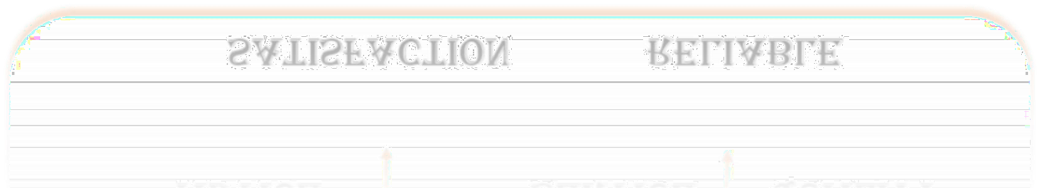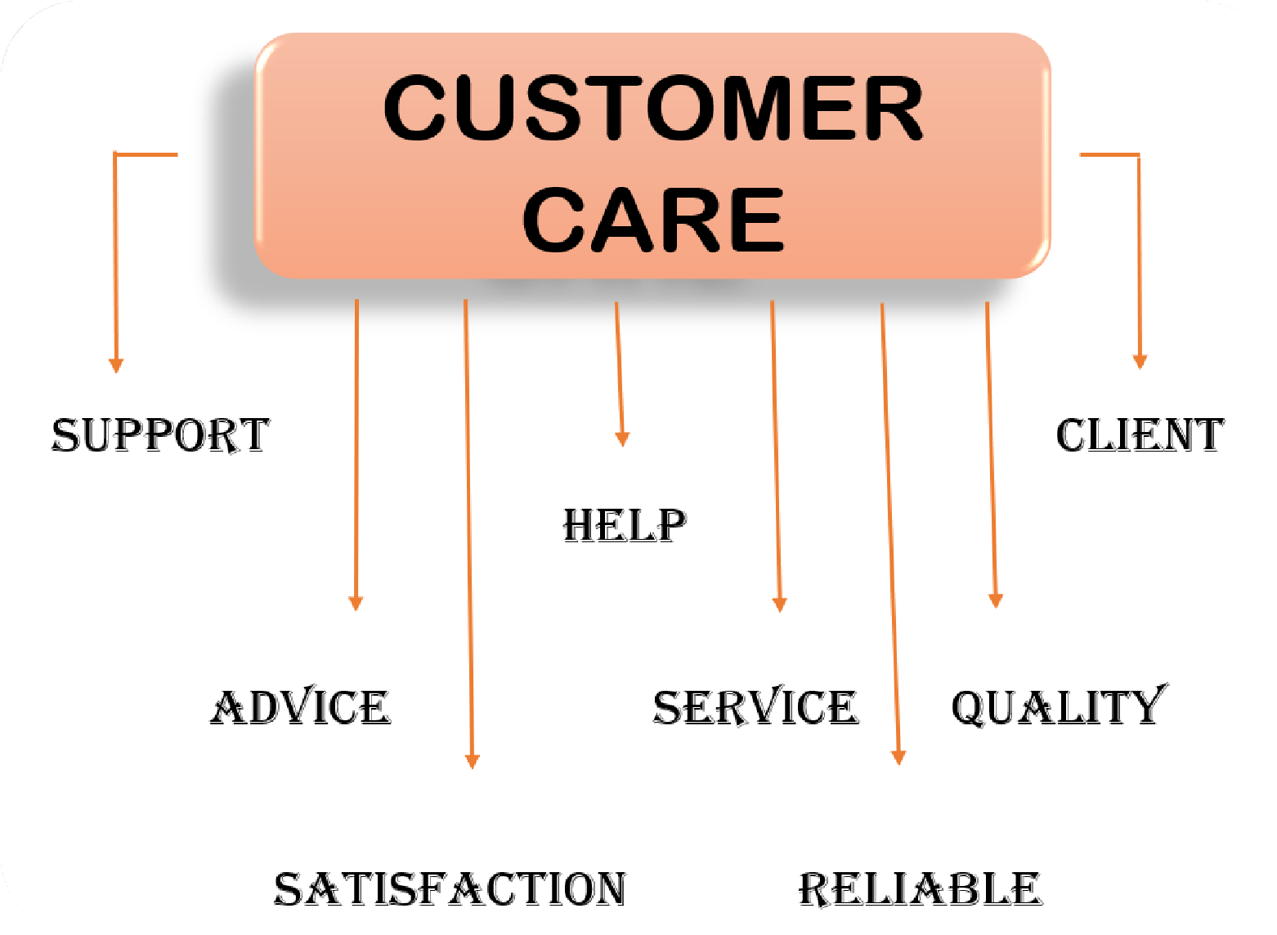

I

Customer Journey Map

***Thank you***

Customer Journey Map